Darsh Jaiswal – Systems & AI Automation Intern (Round 2)
Myntmore | Completed written submission | 31 October 2026
Filled copy of the supplied assignment. Loom recording and share link will be added after recording.

👋 Before You Begin
Please fill in the details below:
Name: Darsh Jaiswal
Email: darshjaiswal1121@gmail.com
Tool choices: n8n for automation and Claude/Anthropic for AI. These replace the Gemini/Make references retained in the original questions. Codex assisted implementation; fixed code controls scores, routing and validation.
Live Hook Grader: https://myntmore-hook-grader-darsh.vercel.app
GitHub repository: https://github.com/darsh-jaiswal/Automation-Intern
Evidence note: the 11 supplied images are earlier implementation explanations, not new live-run screenshots. Original browser captures and verification records are linked below. Task 1 counts refer to the original sample verification; later tool demos added records. No email or external message was sent.

⚙️ Guidelines
- Use our stack: build with the tools listed below, the same ones our team uses every day.
- Think like an operator: handle messy data and failures on purpose, not just the happy path.
- Drafts only: never send an email or message to a real person.
- Keep secrets safe: no API keys or passwords in your repo, screenshots or video.

📚 About Myntmore: Read This First
Myntmore is a B2B growth marketing and AI-led outbound agency based in Mumbai. We help founders, CXOs, and expert-led businesses turn LinkedIn into a predictable engine for qualified sales meetings.
This round is about the system behind our lead magnets: 9 free AI tools on our website. A visitor fills a short form and uses a tool, and each session is saved as one row: who they are, what they typed, and what the tool returned. Sales then tries to book a call through myntmore.com/founder-meeting.

🔗 Resources: Review Before Starting
Website: https://myntmore.com
Free AI tools: https://www.myntmore.com/resources/tools
Product Video: https://www.loom.com/share/143c7b6ae41242bbbad797539987d214
Services Doc: https://myntmoreservices.notion.site/Myntmore-Growth-Marketing-Services-26b522641d388077a463e86ae78f02bc
Sample data: leads.csv, attached to the email (20 fictional tool sessions)

🧰 The Stack: Use These
For | Use
Automation | Make, Zapier, n8n, etc.
AI | Google Gemini (gemini-2.5-flash), with a free API key from Google AI Studio
Database | Supabase
Web app | Next.js, code on GitHub, deployed on Vercel
Video | Loom

Free plans are enough. AI coding assistants such as Claude Code / Codex are fine, as long as you can explain what you built.

📝 The Assignment: 3 Tasks

01) Build the Lead Follow-Up Engine (main task)
Import leads.csv into a Supabase table. It holds 20 fictional tool sessions, and some rows are messy on purpose. Then build an automation using Make, Zapier, n8n:
Answer: The manual n8n workflow starts at “Run sample CSV”, then “Import every original session”. The local worker parses the repository’s leads.csv and stores all 20 original sessions in Supabase before grouping them into 19 contacts. It then processes each person, validates the draft and saves CRM text. Replaying unchanged data preserves session, contact, assessment, draft and alert identities.
- Cleans the data. Handle duplicates, test entries and non-buyers on purpose, and record a reason. Never drop a row silently.
Answer: All 20 raw rows are retained. Karan Shah’s L03 and L11 sessions are linked to one person and used together. L07 is an explicit test; L09 is a student and L14 is a job seeker. They remain saved with a reason and receive no draft. Missing context/email and suspicious instructions are visible review holds. Different people at one company remain separate; a personal email address alone is not an exclusion.
Screenshot 11: Task 1 / duplicates, test entries and non-buyers. Candidate-supplied implementation explanation.
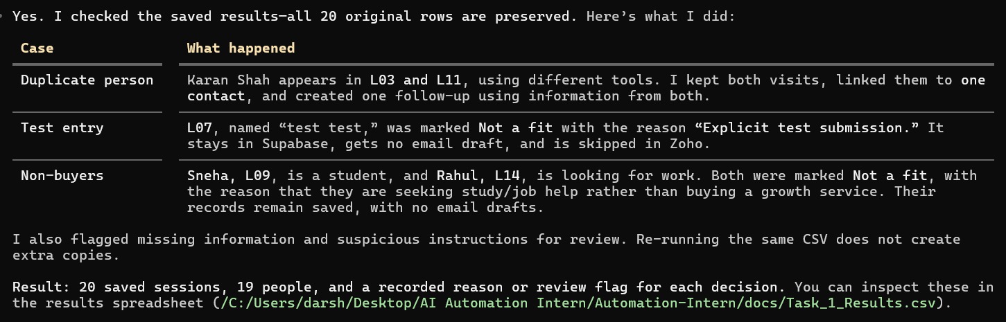
- Scores each lead from 1 to 10 for fit with one of our services (personal branding, LinkedIn outreach, cold email, lead generation), with a one-line reason. Say which parts are rules and which are Gemini.
Answer: Each contact receives a final score from 1–10, a relevant service where supported, and a one-line reason. Claude interprets the business, need and suitable service using the saved input and output. Code adds the points, applies caps and assigns the tier. The full rubric is filled in the scoring box below.
Screenshot 9: Task 1 / lead scoring. Candidate-supplied implementation explanation.
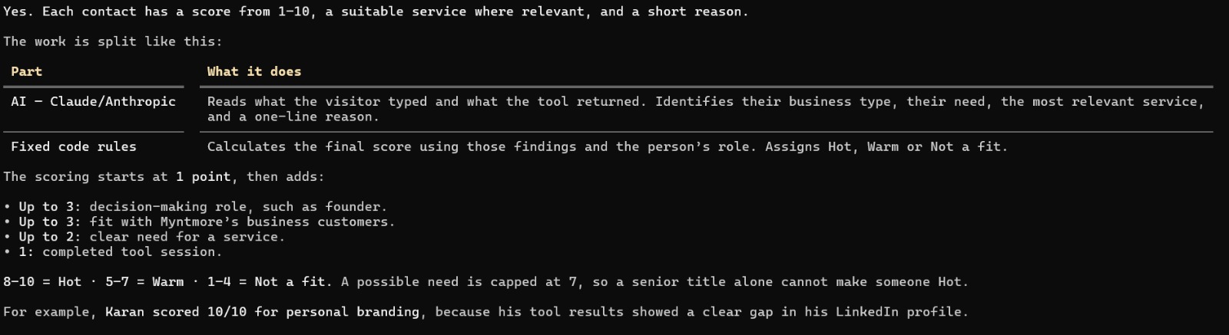
Screenshot 10: Task 1 / rules versus Claude. Candidate-supplied implementation explanation.
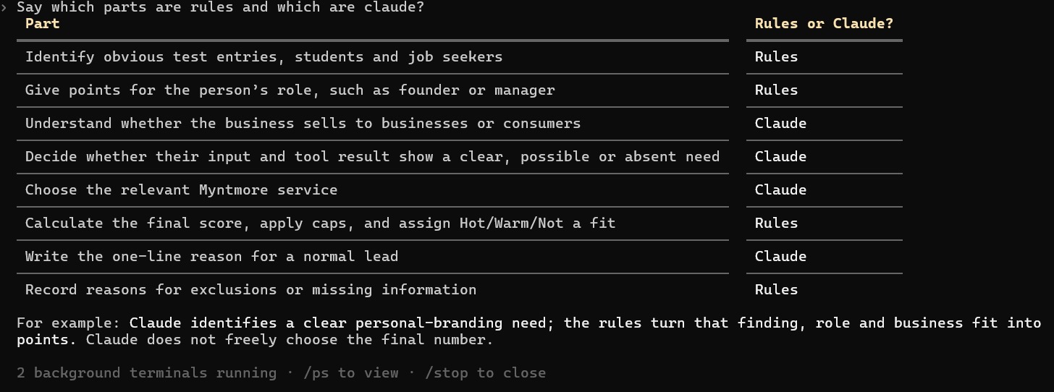
- Writes a follow-up email with Gemini that uses what the lead typed and what the tool returned. No jargon or em dashes, no invented numbers or claims, under 120 words, and only myntmore.com/founder-meeting as the call link.
Answer: Claude writes a context-based subject, advice and invitation using both the visitor’s input and the tool output. Code assembles and checks the draft: subject and body together under 120 words; verified source phrases from both inputs; no selected jargon, em/en dashes or numerical performance claims; only https://myntmore.com/founder-meeting, once. Up to two correction attempts follow the initial attempt, then the result is held for review. These checks still need human review. The original sample produced 12 validated drafts, saved in Supabase and Zoho lead Description; nothing was sent.
Screenshot 8: Task 1 / email writing checks. Candidate-supplied implementation explanation.
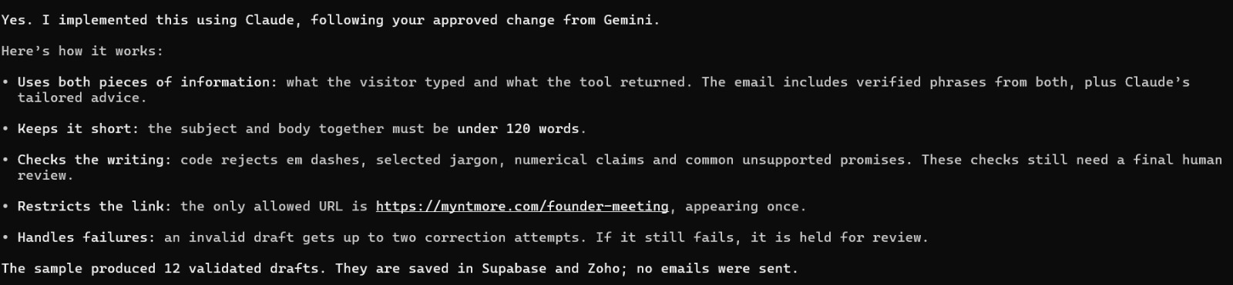
- Routes each lead: Hot (draft email plus an alert), Warm (one nurture email drafted) or Not a fit (tagged with the reason, no email).
Answer: Code routes 8–10 to Hot, 5–7 to Warm and 1–4 to Not a fit. Hot gets a validated draft plus an internal database/dashboard alert and Zoho priority marker; Warm gets one validated nurture draft. Not a fit keeps the reason and gets no draft. Review/error states hold unsafe drafts. Original sample verification: 1 Hot, 13 Warm, 5 Not a fit, 12 validated drafts, 4 review holds, zero processing errors, 17 contacts synced and read back from Zoho. The test record and missing-email record were intentionally skipped in CRM. Zoho stores draft text in Description, rather than a native email draft.
Screenshot 7: Task 1 / routing and follow-up draft summary. Candidate-supplied implementation explanation.
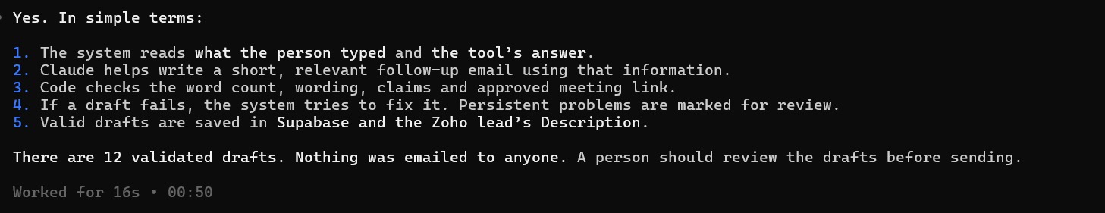
Bonus: enrich leads with company size, funding or LinkedIn activity. Show it on 3 real companies, since the sample people are fictional.
Full sourced enrichment examples
Answer: I manually researched three real companies, separately from the fictional sample people. Razorpay: $375 million funding and about 2,000 employees in its December 2021 announcement. Zoho: privately owned and self-funded, per its official statement. Cursor: $2.3 billion funding and over 300 employees in its November 2025 announcement. Each fact has its first-party source and date. These are dated examples, not current size estimates; automatic enrichment is not implemented.
Screenshot 6: Task 1 / three manual enrichment examples. Candidate-supplied implementation explanation.
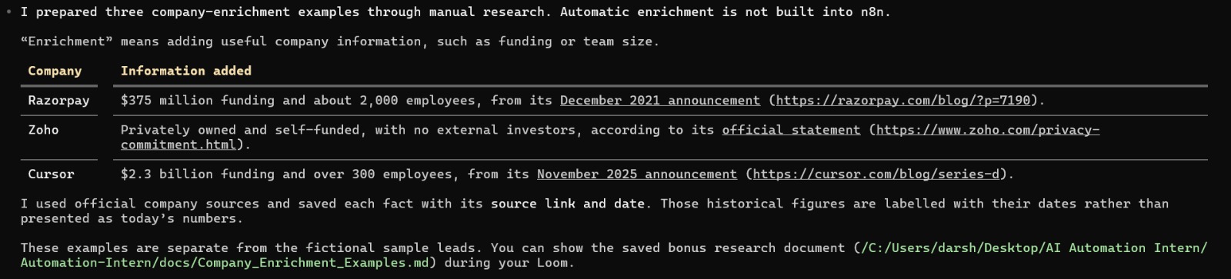
Your scoring rules, and which parts are rules vs Gemini (implemented with Claude):
Final score = 1 base point + role (0–3) + business fit (0–3) + relevant need (0–2) + completed tool activity (0–1). Founders/decision makers can earn up to 3 role points; B2B fit up to 3; clear need 2 or possible need 1.
Caps: possible/adjacent need or consumer-facing context cannot exceed 7; no evidenced relevant need cannot exceed 4. Explicit test/job-seeker exclusions receive 1 and no draft. Missing data, suspicious input or failed analysis is flagged for review.
Rules: preserve and group sessions, exclusions, role points, arithmetic/caps, Hot/Warm/Not a fit, draft checks, retries, storage and CRM deduplication. Claude: interpret business type and input/output need, select a service, provide supporting evidence and the normal lead’s one-line reason, and write the draft content.
Hot 8–10; Warm 5–7; Not a fit 1–4. A senior title alone cannot make a weak-fit lead Hot. Example: Karan’s two sessions support a personal-branding need; his final score was 10. These rules are design choices, not a measured sales-conversion predictor.

02) Ship a 10th Free Tool: the LinkedIn Hook Grader
A visitor pastes the first two lines of a LinkedIn post and gets a score and 3 rewrites. Try our LinkedIn Profile Optimizer first to see the pattern.
- Build it in Next.js on Vercel: a landing screen, a contact form (name, designation, email), the tool, then the results.
Answer: Built in Next.js and deployed at the live URL above. The visitor sees a landing page, enters name/designation/email and accepts the storage notice, pastes one or two hook lines, then sees a score, failed-check feedback and three rewrites with Copy buttons. Desktop and mobile production checks are recorded.
Screenshot 1: Task 2 / visitor flow and Vercel deployment. Candidate-supplied implementation explanation.
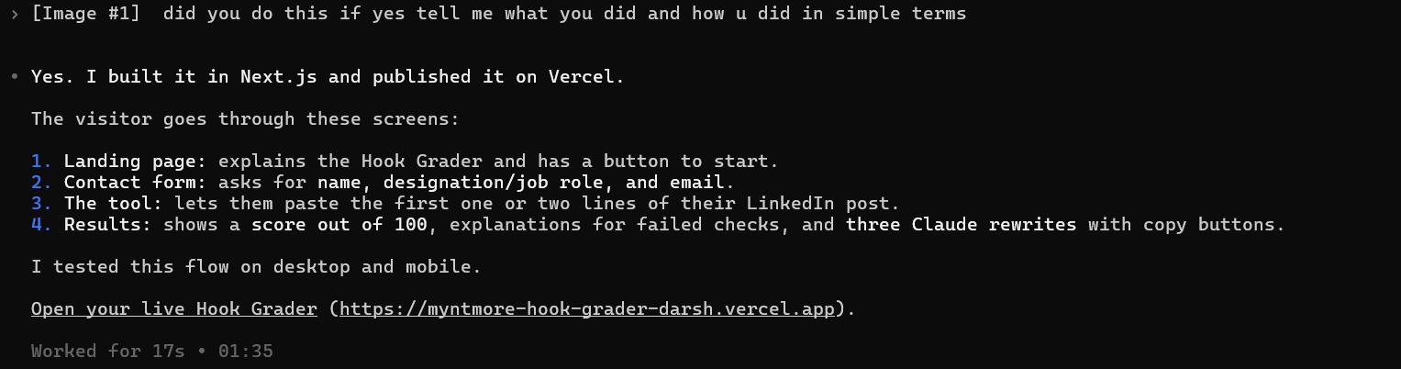
- Score the hook with code, not AI: 4 to 6 rules, a score out of 100, and one line for each rule that fails. The same hook always gets the same score.
Answer: The same normalised hook always receives the same score. Six code rules total 100 points: 8–40 words (20); first line 4–18 words (20); reader focus (15); question/curiosity/contrast (20); concrete subject/example (15); plain wording without selected jargon, guarantees, em/en dashes, links or hashtags (10). Each rule passes for its full points or fails for zero with one line of feedback. Claude does not decide the score. This is a writing checklist, not a prediction of post reach.
Screenshot 2: Task 2 / six fixed scoring rules. Candidate-supplied implementation explanation.
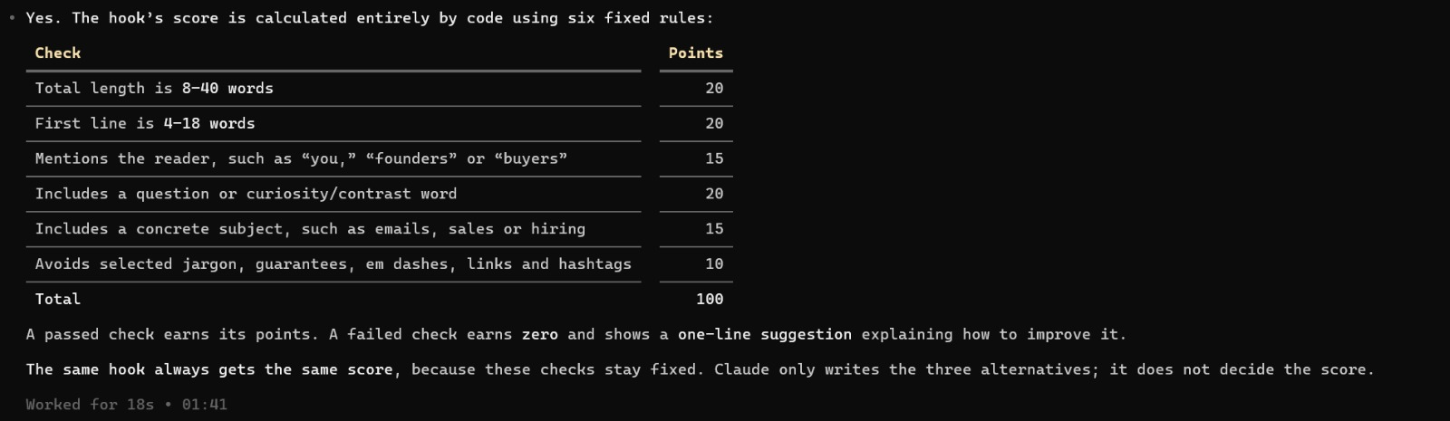
- Get 3 rewrites from Gemini as structured JSON (responseSchema), following the Task 01 writing rules.
Answer: Claude returns JSON with exactly direct, curiosity and contrast fields using its JSON-schema structured-output setting. Code checks that all three rewrites exist, differ, stay within one/two lines and under 120 words, and avoid selected jargon, dashes, added numbers, unsupported generalisations and links. The prompt requires preserved meaning and no invented facts. Failed output gets up to two corrections, then a visible review/error state. Hook rewrites contain no call link; the approved booking link is added only to the separate Task 1 follow-up.
Screenshot 3: Task 2 / structured rewrites and validation. Candidate-supplied implementation explanation.
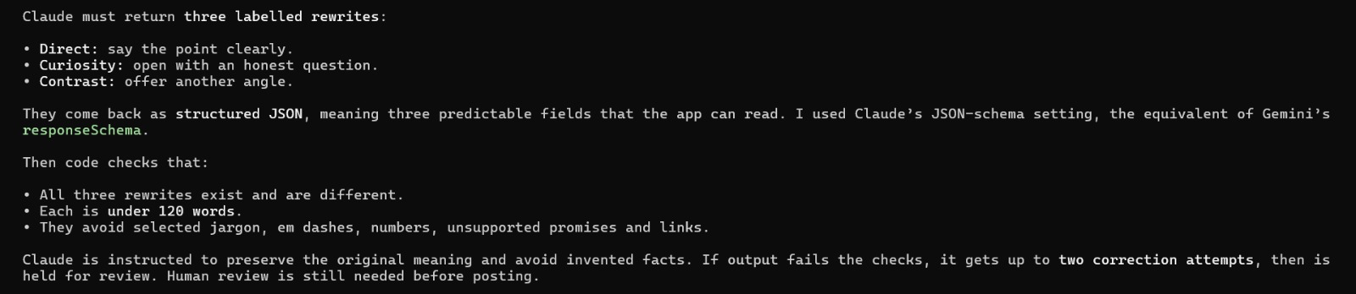
- Save each session (contact, hook, score, rewrites) as one row in Supabase, and send it to your Task 01 scenario through a Make.com webhook.
Answer: One request UUID identifies one Supabase session row containing contact details, original hook, code score, rule feedback and rewrites/model status. Failures remain recorded. A durable Supabase delivery queue lets the local relay send the saved session to the authenticated n8n Task 1 webhook. Task 1 processes the lead and stores the follow-up in Zoho Description. Successful replays do not create another session row. The worker, n8n and relay must be running; otherwise delivery waits in the saved queue. Live browser-to-Supabase-to-n8n-to-Zoho read-back was verified.
Screenshot 4: Task 2 / saved session and n8n delivery. Candidate-supplied implementation explanation.
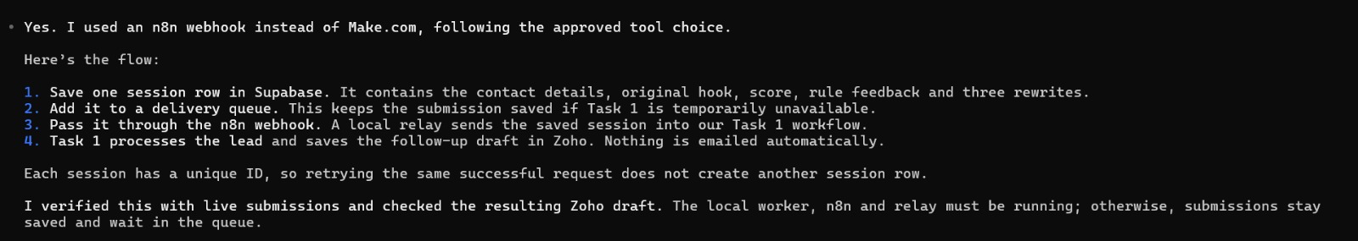
One plain page is enough.
Task 2 production verification record
Original desktop and mobile browser screenshots

03) Ops Judgement (written, 1 page max)
Answer each question in the space below it.
Task 3’s written answer is also supplied as a one-page PDF. The detailed 15-row comparison and screenshot evidence are an appendix, as the supplied table already spans multiple pages.
Task 3: one-page written answer

3a. A silent bug
Leads from the Battle Card and Case Study tools reach Zoho CRM, but Supabase has none of their sessions. The other 7 tools are fine. What is wrong, how do you fix it, and how do you stop it from failing silently again?

constraint leads_source_check check (source in (
'roi_calculator', 'icp_builder', 'profile_optimizer',
'dm_angle_generator', 'lead_magnet_ideas',
'posting_rhythm_builder', 'founder_presence_analyzer'
))
async function saveLead(source: LeadSource, lead: LeadForm) {
postToZohoForm(source, lead);
const { data, error } = await supabase
.from("leads").insert({ source, ...lead }).select().single();
if (error) console.error("lead insert failed", error);
return data?.id; // later used to save the tool's inputs and outputs
}
Your answer:
What is wrong: leads_source_check allows only seven source names. Battle Card and Case Study are missing, so their database inserts fail (PostgreSQL 23514). Zoho is called independently before the database write and is not awaited. The error is only logged; returning data?.id leaves no lead ID for the session save.
Fix: confirm the emitted source IDs and add the missing values in a versioned migration, preserving the existing seven. Keep frontend/API/database source lists aligned, including the tenth tool. Save the lead, session and durable CRM-sync job in one database transaction. Show failure unless the database work commits. Then a worker awaits Zoho, records the result and retries temporary failures with an idempotency key. A database transaction cannot make a Zoho HTTP request atomic.
Prevent recurrence: test all sources, unknown sources, insert failures and CRM retries. Alert on persistent failures and compare completed runs with database sessions and CRM records by source/session ID. Recover missing sessions from retained logs with original IDs/timestamps where possible; label unrecoverable data and avoid blind CRM replay. This is an analysis of the supplied snippet, not a production schema change.

Screenshot 5: Task 3a / bug diagnosis, fix and prevention. Candidate-supplied implementation explanation.
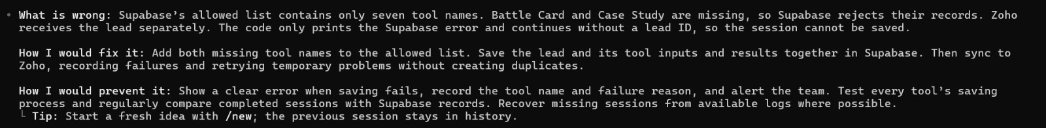

3b. AI search
Ask ChatGPT, Perplexity and Gemini 5 questions a potential client would ask. Does Myntmore appear, and who appears instead? Name the 3 website changes you would make first.
Answer: All 15 real answers were collected on 31 October 2026 IST, using the same five neutral prompts in fresh conversations. Myntmore appeared in 4/15: Q1 ChatGPT #2, Perplexity #1 and Gemini #1; Q3 Perplexity #4. It was absent from all Q2, Q4 and Q5 answers. ChatGPT was signed-in Instant (Plus); Gemini signed-out Flash-Lite; Perplexity Q1 signed out and Q2–Q5 signed in on Free, with an automatic Pro preview on Q2. These differences limit comparison. Positions are answer order, not stable rankings. AI claims and URLs are preserved, including errors; citation-chip targets were not all expanded.
Results
# | AI | Question asked | Does Myntmore appear? (Yes/No, position) | Who appears instead | What the answer said (1 line) | Sources the AI cited | Screenshot
1 | ChatGPT | Which agencies in Mumbai help B2B founders get qualified sales meetings through LinkedIn outreach? Please name up to five suitable agencies, give a short reason for each, and cite the sources you used. If you cannot verify an agency, say so. | Yes; 2 | LinkLoom; SG B2B Business Leads; Pixelo Digital; DemandFluence | Listed Myntmore second and included it in the final shortlist; performance claims were not independently verified. | 1. Appointment-setting services  2. Agency website  3. Agency website  4. Agency website  5. Agency website  Visible labels: LinkLoom +1; AI-Powered B2B Lead Generation Agency, Mumbai +1; LinkedIn; Client Magnet; Lemniscate Growth +1 | Capture 1  Capture 2  Capture 3
1 | Perplexity | Which agencies in Mumbai help B2B founders get qualified sales meetings through LinkedIn outreach? Please name up to five suitable agencies, give a short reason for each, and cite the sources you used. If you cannot verify an agency, say so. | Yes; 1 | AAmber Communications LAB; Lemniscate Growth | Listed Myntmore first; gave only three names and qualification caveats for the alternatives. | 1. revenuebase  2. revenuebase  3. lemniscategrowth | Capture 1
1 | Gemini | Which agencies in Mumbai help B2B founders get qualified sales meetings through LinkedIn outreach? Please name up to five suitable agencies, give a short reason for each, and cite the sources you used. If you cannot verify an agency, say so. | Yes; 1 | The Adroit; Kology; BrandEar; Weezly | Listed Myntmore first for Mumbai LinkedIn outreach; one Myntmore source target was misspelled. | 1. Myntmore Official Website  2. The Adroit LinkedIn Marketing Services  3. Kology LinkedIn Lead Generation Services  4. BrandEar LinkedIn Marketing & Thought Leadership  5. Weezly Lead Generation Agencies in India | Capture 1
2 | ChatGPT | Which agencies can improve an Indian B2B founder's LinkedIn profile and personal brand to attract business enquiries? Please name up to five suitable agencies, give a short reason for each, and cite the sources you used. If you cannot verify an agency, say so. | No; Not listed | FableSquare; DoTheNew; UVOKA; Boldface; BeNoStranger | Recommended founder-branding specialists; stressed qualified enquiries and case evidence rather than follower counts. | 1. FableSquare  2. DoTheNew  3. UVOKA  4. Boldface  5. BeNoStranger  Visible labels: FableSquare; A LinkedIn Personal Branding Studio; LinkedIn Personal Branding Agency; Boldface; LinkedIn | Capture 1  Capture 2  Capture 3
2 | Perplexity | Which agencies can improve an Indian B2B founder's LinkedIn profile and personal brand to attract business enquiries? Please name up to five suitable agencies, give a short reason for each, and cite the sources you used. If you cannot verify an agency, say so. | No; Not listed | BeNoStranger; SackBerry Media; Brand U by SamparkSeSampark; LYNQD; Brandastics | Recommended founder-branding specialists using public LinkedIn profiles; asked for named, checkable case studies. | 1. linkedin  2. linkedin  3. linkedin  4. linkedin  5. linkedin  Visible labels: linkedin; linkedin +1; linkedin +2 | Capture 1  Capture 2  Capture 3  Capture 4
2 | Gemini | Which agencies can improve an Indian B2B founder's LinkedIn profile and personal brand to attract business enquiries? Please name up to five suitable agencies, give a short reason for each, and cite the sources you used. If you cannot verify an agency, say so. | No; Not listed | Ohh My Brand; Moris Media; ROI Hunt; The People Company; Vajra Global | Recommended founder/personal-branding providers without naming Myntmore. | Visible citation labels: Ohh My Brand; Moris Media; ROI Hunt; Vajra Global. The answer also describes agency portfolios and directories, but no explicit URL targets were captured. | Capture 1
3 | ChatGPT | Which agencies help Indian B2B SaaS companies set up cold email outreach, including deliverability and lead targeting? Please name up to five suitable agencies, give a short reason for each, and cite the sources you used. If you cannot verify an agency, say so. | No; Not listed | Digital Patron; Blueberg; Inboxist; growth.cx; Modern Inbound | Recommended cold-email specialists with targeting and deliverability infrastructure; warned results were not independently verified. | 1. Digital Patron  2. Blueberg  3. growth.cx  4. Modern Inbound  Visible labels: Digital Patron +1; Blueberg; a-us.storyblok.com; moderninbound.com | Capture 1  Capture 2  Capture 3
3 | Perplexity | Which agencies help Indian B2B SaaS companies set up cold email outreach, including deliverability and lead targeting? Please name up to five suitable agencies, give a short reason for each, and cite the sources you used. If you cannot verify an agency, say so. | Yes; 4 | Digital Patron; growth.cx; Client Magnet; Balistro | Listed Myntmore fourth and linked its Bengaluru lead-generation page; emphasised deliverability and ICP-based targeting. | 1. growth  2. clientmagnet  3. myntmore  4. balistro  5. moderninbound  Visible labels: digitalpatron +1; growth; clientmagnet; myntmore; balistro; moderninbound | Capture 1  Capture 2  Capture 3  Capture 4
3 | Gemini | Which agencies help Indian B2B SaaS companies set up cold email outreach, including deliverability and lead targeting? Please name up to five suitable agencies, give a short reason for each, and cite the sources you used. If you cannot verify an agency, say so. | No; Not listed | Modern Inbound; Leadle; Kology; SalesAladin; Blueberg | Focused on cold-email infrastructure, warm-up, deliverability and targeting; Myntmore was absent. | 1. https://moderninbound.com/blog/best-cold-outreach-agencies-in-india  2. https://www.salescaptain.io/cold-outreach-agencies/best-cold-outreach-agencies-in-india  3. https://moderninbound.com/blog/best-cold-outreach-agencies-in-india  4. https://www.kology.co/cold-email-outreach-services/  5. https://moderninbound.com/blog/best-cold-outreach-agencies-in-india  6. https://www.blueberg.in/lead-gen | Capture 1
4 | ChatGPT | Which agencies help Indian manufacturers and exporters find overseas B2B buyers using LinkedIn and email outreach? Please name up to five suitable agencies, give a short reason for each, and cite the sources you used. If you cannot verify an agency, say so. | No; Not listed | Rysaa; Go For It; Global Trade Alliance; Flint Leads; gaa-tha | Recommended export-focused providers offering buyer discovery and LinkedIn/email campaigns; asked for product- and market-specific proof. | 1. Rysaa — Corridor  2. Go For It — International Growth  3. Global Trade Alliance (India)  4. Flint Leads  5. gaa-tha  Visible labels: Export Growth Partner for Indian Manufacturers; Go For It; Global Trade Alliance; LinkedIn; gaa-tha | Capture 1  Capture 2  Capture 3
4 | Perplexity | Which agencies help Indian manufacturers and exporters find overseas B2B buyers using LinkedIn and email outreach? Please name up to five suitable agencies, give a short reason for each, and cite the sources you used. If you cannot verify an agency, say so. | No; Not listed | Export Buyer Finding; PromotEdge; Rasp International; Meriton / Export Plus; Four Turrets | Recommended export specialists with documented LinkedIn/email buyer outreach; qualified their unverified results. | 1. linkedin  2. promotedge  3. raspinternational  4. meriton  5. fourturrets  Visible labels: linkedin; promotedge; raspinternational; meriton; fourturrets | Capture 1  Capture 2  Capture 3  Capture 4
4 | Gemini | Which agencies help Indian manufacturers and exporters find overseas B2B buyers using LinkedIn and email outreach? Please name up to five suitable agencies, give a short reason for each, and cite the sources you used. If you cannot verify an agency, say so. | No; Not listed | Gaa-tha; Nebula; Kology; SalesCaptain | Named four export/B2B outreach providers; did not include Myntmore. | 1. Gaa-tha - B2B & Export Lead Generation Services  2. Nebula Tech - Digital Marketing for Export-Focused Manufacturers  3. Kology - LinkedIn Lead Generation Services  4. SalesCaptain - Top Cold Outreach Agencies in India | Capture 1
5 | ChatGPT | Which agencies in Mumbai build AI-powered lead generation and follow-up automation connected to Zoho CRM? Please name up to five suitable agencies, give a short reason for each, and cite the sources you used. If you cannot verify an agency, say so. | No; Not listed | Visiosoft Solutions; Uginix; Tech Magify LLP; Leveledge; Shyphan AI Solutions | Favoured explicit Zoho and AI implementation evidence, while qualifying several firms whose AI capabilities remained unverified. | 1. AI automation services  2. CRM automation services  3. Zoho CRM services  4. Zoho integration services  5. Mumbai Zoho and AI services  Visible labels: Visiosoft Solutions +1; Uginix; Tech Magify +1; Leveledge; Shyphan AI | Capture 1  Capture 2  Capture 3  Capture 4
5 | Perplexity | Which agencies in Mumbai build AI-powered lead generation and follow-up automation connected to Zoho CRM? Please name up to five suitable agencies, give a short reason for each, and cite the sources you used. If you cannot verify an agency, say so. | No; Not listed | Tech Magify LLP; The Works; 4Byte Agency; WhizCrow Technologies; CirroCraft | Favoured Zoho implementation evidence and qualified several candidates whose Zoho or AI capabilities were unverified. | 1. techmagify  2. techmagify  3. techmagify  4. theworks  5. theworks  6. 4byte  7. 4byte  8. zeroado  9. agencies.semrush  10. justdial  Visible labels: techmagify +2; theworks +1; 4byte +1; zeroado +1; justdial; techmagify +3 | Capture 1  Capture 2  Capture 3  Capture 4
5 | Gemini | Which agencies in Mumbai build AI-powered lead generation and follow-up automation connected to Zoho CRM? Please name up to five suitable agencies, give a short reason for each, and cite the sources you used. If you cannot verify an agency, say so. | No; Not listed | Visiosoft Solutions; Tech Magify LLP; Codelattice; GInfomedia; Infobyd | Recommended AI automation and Zoho implementation providers; Myntmore was absent. | 1. visiosoftsolutions.com/ai  2. techmagify.com  3. codelattice.com  4. ginfomedia.in  5. infobyd.com | Capture 1
Your 3 website changes
# | Website change | Why (what you saw in the answers above) | Which questions it would help
1 | Improve existing founder-branding, SaaS cold-email and exporter pages with concise buyer-question answers, clear deliverables and relevant case-study links. | Myntmore was absent from all three Q2 and Q4 answers. Specialist providers had more explicit service or founder-profile evidence. | Q2, Q3, Q4
2 | If Zoho automation is offered to clients, publish a Zoho-specific implementation walkthrough with a redacted lead-to-CRM flow and retry ownership. | All three Q5 answers favoured explicit Zoho providers. The checked AI Lead Generation page does not mention Zoho. | Q5
3 | Strengthen case studies with dates, baselines and client-approved attribution or independent references, linked from service pages and the buyer guide. | ChatGPT and Perplexity repeatedly distinguished advertised capabilities from verified results. The checked founder case study uses an anonymous client description. | Q1, Q2, Q3, Q4, Q5

🎥 Walk Us Through It on a Loom
Record one video, 5 to 7 minutes long, with your camera on. Show us these four things, in this order:
- Your follow-up engine (Task 01) working: run it on leads.csv and show the results in Zoho CRM.
- Your Hook Grader (Task 02) working: use it like a visitor would
- How you built it: walk through your automation. Point out which steps follow fixed rules you wrote and which steps use Gemini.
- What's missing: what doesn't work yet, and what you would fix next with more time.
Clear and honest beats polished. We want to hear what you think.

🎯 What We Are Actually Evaluating
- It works end to end (25%): Task 01 on the sample leads, and a Task 02 lead flowing through it
- Follow-up quality (15%): personal, and following the writing rules
- Built to reuse (15%): easy to add a tool or a rule, and failures are visible
- The Hook Grader (15%): deployed, a consistent score, structured AI output
- Messy data (10%): every odd row handled on purpose
- Judgement (10%): your Task 03 answers
- Initiative and communication (10%): going beyond the brief, and explaining it simply

💡 One Thing Before You Start
Open leads.csv and read every row before you build anything. Real form data is messy, and how you handle the odd rows will tell us more than how polished your workflow looks.

📤 Submission
- Submission name: Darsh Jaiswal – Systems & AI Automation Intern (Round 2)
- Fill in your links in the table below
- Ensure all Drive links are set to Anyone with the link can view
- Save as PDF and reply to the same email thread with the attached file
Submission status: written answers and evidence filled; Loom recording/link remains. No candidate Drive link is used here. The original resource video above belongs to the assignment and is not my Loom submission. Attach this PDF when replying to the original email thread after adding the Loom link.
Limitations: local worker/n8n/relay require this computer to remain online. Production hosting for them, automatic enrichment and stronger abuse protection are future work. AI drafts and semantic claims need human review. Code supports a Gemini option in Task 1, but the verified runs and Hook Grader use Claude. No email or message was sent.
Task 1 results: 20 original sessions and recorded decisions
Task 1 verification, recorded 30 October 2026
Task 2 live verification
Task 3 original answers, sources, dates and all captures
Public-release security check

Item | Link
Loom video | To be added after the candidate records the Loom video.
Live Hook Grader URL | https://myntmore-hook-grader-darsh.vercel.app
GitHub repo | https://github.com/darsh-jaiswal/Automation-Intern

Good luck. We are rooting for you.

